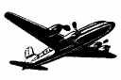 The Berlin Airlift 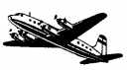

Introduction

At the end of World War II, Britain, France, the United States, and the Soviet Union each occupied a section of Germany. Each country also controlled a zone within the capital city of Berlin, which was located inside of the Soviet section (see maps on next page). Between 1947 and 1948, cooperation between the Western powers and the Soviet Union broke down and the Western Allies decided to create a separate government within their zones. In an effort to dissuade them, the angered Soviets blockaded the city of Berlin on June 24, 1948.

In order to keep the city alive, Britain, France, and the United States worked together to airlift all necessary supplies into the city. Food, coal, and industrial supplies were flown into the city on a round-the-clock basis. Soldiers even parachuted chocolate bars into the city for Berlin children. It seemed like an impossible task to keep the entire city functioning using only air power, but President Truman made a momentous decision, stating that, “… we are going to stay-period."

Despite bad weather, fatigue, and dangerous flying conditions, pilots managed to actually increase the amount of supplies brought into the city over time (leaders put crews into a healthy competition with one another in order to boost both morale and the quantity of supplies flown). On April 16, 1949, the Combined Airlift Task Force mounted its maximum effort in what came to be known as the “Easter Parade.” That day 1,398 flights brought 12,940 tons of supplies into Berlin.

Finally realizing that the Western powers were not going to give up on the city, the Soviets lifted the blockade on May 12, 1949.

Berlin Airlift Statistics

 | Number of Flights | Tons of Cargo
United States | 189,963 | 1,783,573
Britain | 87,841 | 541,937
France | 424 | 896
Total | 278,228 | 2,326,406

*A comparison with the recent multinational airlift into Sarajevo suggests how intense an effort the Berlin Airlift was. From July 1992 to January 1996, 179,910 tons of cargo was airlifted into Sarajevo. In contrast, the Berlin Airlift delivered more than that amount in March 1949 alone, using smaller aircraft and less sophisticated technology.

The Berlin Airlift

Student Activity

Using the introduction information, answer the following questions. Round all of your answers to the nearest whole number and be sure to show your work.

- During the Easter Parade, approximately how many flights came into Berlin per hour? How many came in per minute?

- Assuming that each plane carried the same amount of cargo, how many tons of supplies did each flight bring into Berlin during the Easter Parade? What would that amount be in pounds?

- What percent of the number of flights did each country (U.S., Britain, and France) contribute? What percent of the total tons of cargo did each contribute?

- Comparing the 1990s airlift in Sarajevo to the 1940s airlift in Berlin – approximately what percent tons of cargo did the 1990s lift compared to the 1940s lift?

- Finally, how many pounds of supplies were airlifted into Berlin, in total?

Berlin Airlift Maps

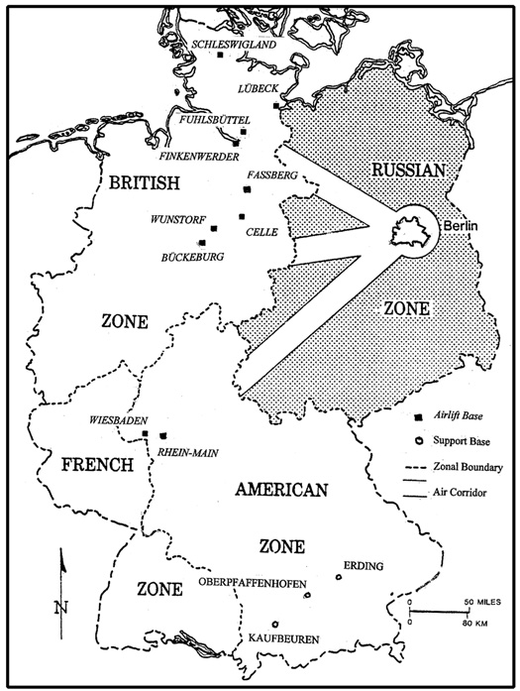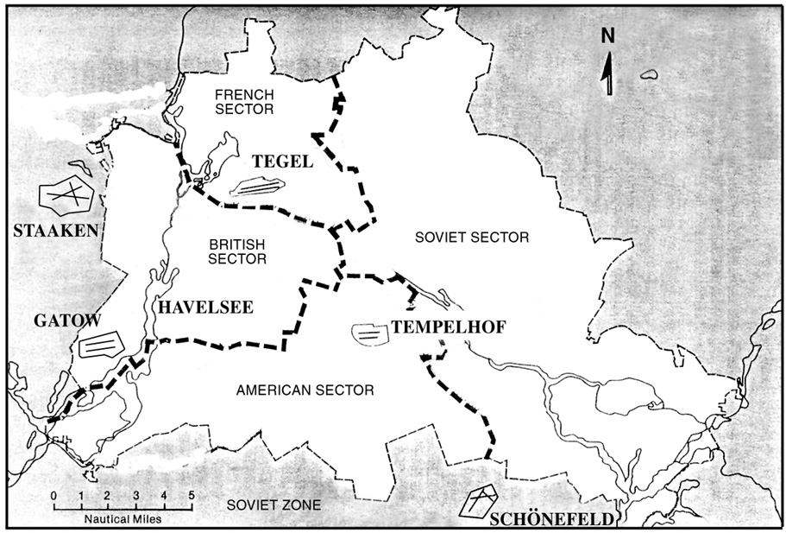
Berlin Airlift Flight Corridors Partitioning of the city of Berlin

The Berlin Airlift

Answer Key

- During the Easter Parade, approximately how many flights came into Berlin per hour? How many came in per minute?
24/1,398 = approximately 58 flights per hour and
58/60 = 1 flight per minute

- Assuming that each plane carried the same amount of cargo, how many tons of supplies did each flight bring into Berlin during the Easter Parade? What would that amount be in pounds?
1,398/12,940 = approximately 9 tons and
9 x 2,000 = 18,000 pounds of cargo on each plane

- What percent of the number of flights did each country (U.S., Britain, and France) contribute? What percent of the total tons of cargo did each contribute?
U.S. – 189,963/278,228 = 68% of flights and
1,783,573/2,326,406 = 77% of cargo

Britain – 87,841/278,228 = 32% of flights and
541,937/2,326,406 = 23% of cargo

France – less and 1% of each flights and cargo

- Comparing the 1990s airlift in Sarajevo to the 1940s airlift in Berlin – approximately what percent tons of cargo did the 1990s lift compared to the 1940s lift?
179,910/2,326,406 - the effort in Sarajevo lifted about 8% of what the Berlin effort lifted

- Finally, how many pounds of supplies were airlift into Berlin, in total?
2,326,406 x 2,000 = 4,652,812,000 pounds of supplies were airlifted

