Berlin Airlift
Interactive Map Activity

Directions

- To find the CNN Interactive Map, go to:
http://edition.cnn.com/SPECIALS/cold.war/episodes/04/
Click on the Berlin Airlift Map.
- Study the map and read the introductory information. Then, click on the various flight corridors and the city of Berlin to find out more information about the airlift.
- Once you have finished examining the interactive map, use it to answer the following questions.

Questions

- How long did it take to build the Tegal Airport? ___________________________________
How many Berlin citizens helped build the airport? _________________________________
- What was the American nickname for the airlift operation? ___________________________
What was the British nickname for it? ___________________________________________
3. How long did the Berlin airlift last? _____________________________________________
(Note: The above answer is how long the airlift lasted under the blockade – supplies continued to be sent into Berlin for four months after the blockade was lifted, in order to stockpile supplies for the city.)
4. How many Berlin citizens were flown out of the city during the airlift? _________________
How many of those Berliners were children? ______________________________________

Berlin Airlift Maps

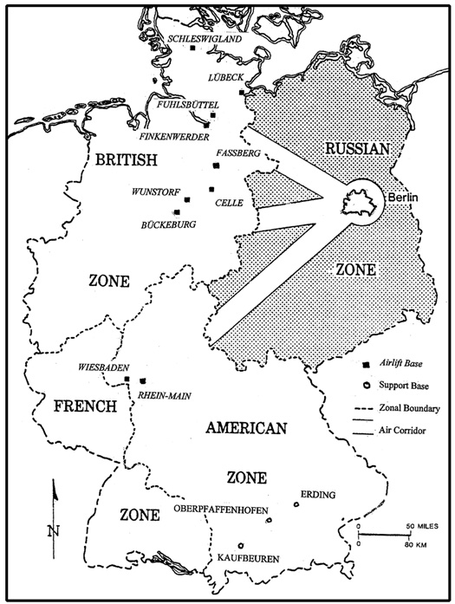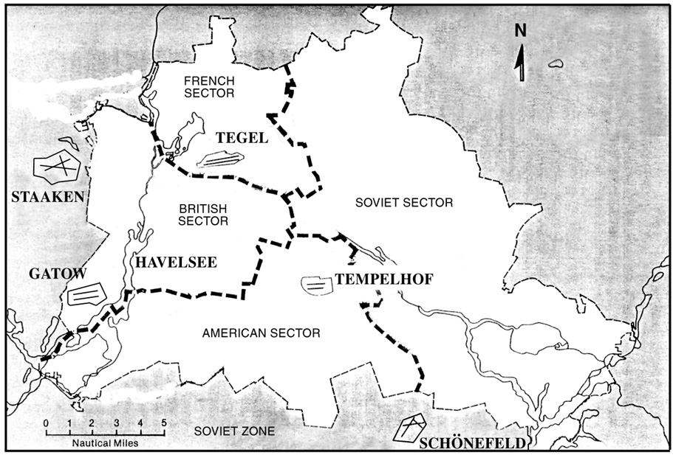
Berlin Airlift Flight Corridors Partitioning of the city of Berlin

Berlin Airlift
Interactive Map Activity
Teacher’s Guide

Directions

- To find the CNN Interactive Map, go to:
http://edition.cnn.com/SPECIALS/cold.war/episodes/04/
*This site also contains valuable maps for the Iron Curtain, the Marshall Plan, the Korean War, and many more.
- Click on the Berlin Airlift Map.
- Study the map and read the introductory information. Then, click on the various flight corridors and the city of Berlin to find out more information about the airlift.
- Once you have finished examining the interactive map, use it to answer the following questions.

Questions

- How long did it take to build the Tegal Airport? 93 days
How many Berlin citizens helped build the airport? 17,000
- What was the American nickname for the airlift operation? Operation Vittles
What was the British nickname for it? Operation Plane Fare
3. How long did the Berlin airlift last? 11 months
(Note: The above answer is how long the airlift lasted under the blockade – supplies continued to be sent into Berlin for four months after the blockade was lifted, in order to stockpile supplies for the city.)
4. How many Berlin citizens were flown out of the city during the airlift? 160,000
How many of those Berliners were children? 15,000

Additional Information

More information, including primary source documents, concerning the Berlin airlift can be found on the Truman Library’s web site at the following web address:

http://www.trumanlibrary.org/whistlestop/study_collections/berlin_airlift/large/docs.php

