1948 Campaign Cartoon

Introduction

Most students are familiar with the traditional comic strip. Whether they collect comic books or simply read the cartoons in the morning newspaper, students are able to understand the meaning and humor of classic cartoons. The majority of students, however, are not familiar with the more sophisticated political cartoon. This lesson is designed to introduce students to political cartoons by drawing on their already present knowledge of classic comic strips. They will become familiar with cartoon techniques such as symbolism, caricature, and satire, and learn to analyze modern political cartoons.
NOTE: Students will need a brief introduction to the 1948 election prior to this activity – who ran, why the Democratic Party split, who won, and what the surprise was.

Directions

- Begin with a discussion of political cartoons. Ask students how they differ from regular comic strips. What is their purpose? Are they supposed to be funny? Are they biased or do they have an agenda? You may consider making a chart on the board listing the similarities and differences between the two types of comics.
- Divide the class into small groups and pass out the cartoon, questions, and analysis sheet. Ask students to first spend a couple of minutes studying the cartoon. They should fill out the analysis sheet and then answer the questions as best they can.
- Once all of the groups have finished their worksheets, meet together again as a class to compare answers. Did different groups pick out different symbols or meaning? Where they all able to explain their answers? Could they all understand the cartoon in the end?
- As a follow-up activity, you may ask students to bring in current political cartoons and explain them to the class – this is a great way to keep up on current events!
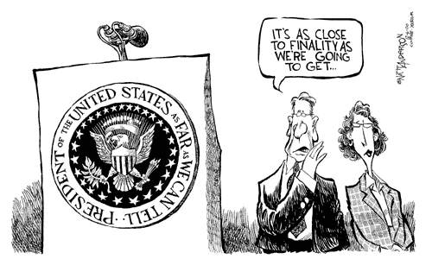

©2000, The Washington Post. Reprinted with permission.

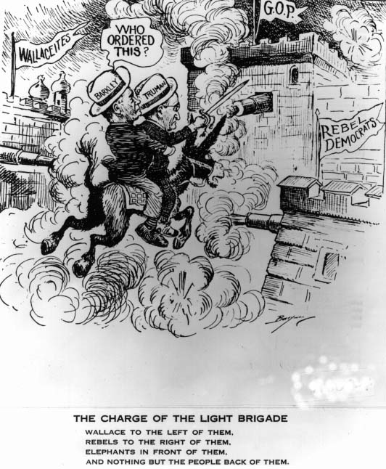

©1948, The Washington Post. Reprinted with permission.

- What do the terms “left” and “right” mean politically?

- What does the donkey symbolize in this cartoon?

- What does G.O.P stand for?

- What battle is Truman charging into? Did he win this battle?

- What is the cartoonist’s message here? Is he writing for or against Truman?

