1948 Campaign Cartoons
Teacher’s Guide

Introduction

Introduce the cartoon analysis activity by engaging the students in a discussion about political cartoons. Point out that while these comics are often humorous, their main function is to express political opinions about officials, issues, or events. Also, point out how critical the use of symbols is to political cartoonists. You may wish to quickly brainstorm with the class common political symbols and their meanings, for example the Republican elephant, the Democratic donkey, the Liberty Bell, or the flag of Freedom.

Procedure

Pass out the cartoons and the Cartoon Analysis Worksheet. If necessary, you may wish to go through and analyze one of the comics with the class as a whole. You can have the students take the activity home and complete all of them overnight, or the students can break up into groups during class and complete one comic per group (then share their results with the class).

Discussion Questions

First, allow students to ask questions concerning things they didn’t understand in the cartoons. Then, lead them in a discussion about the activity as a whole.

Things you may wish to ask:
- What did you learn about the 1948 election that you didn’t know before?
- Did you find any of the comics funny? Why or why not?
- What specific things can you learn from political cartoons that you may not be able to learn from standard history textbooks?
- Do you think that political cartoons can serve as valuable primary source, or are they simply interesting side-notes to history?
- What symbols did you see used in these cartoons?
- Do you think these comics are pro-Truman or anti-Truman? Why?
- Do you think political cartoons are meant to inform casual readers of political happenings or to amuse already politically-informed readers?

Additional Activities

Ask students to find and bring in a current political cartoon. See if they can assess its meaning and intent based on what they learned in the cartoon analysis activity.

Ask students to identify a current political figure, issue, or event that interests them. Have them draw their own political cartoon satirizing their topic.

1948 Campaign Cartoons

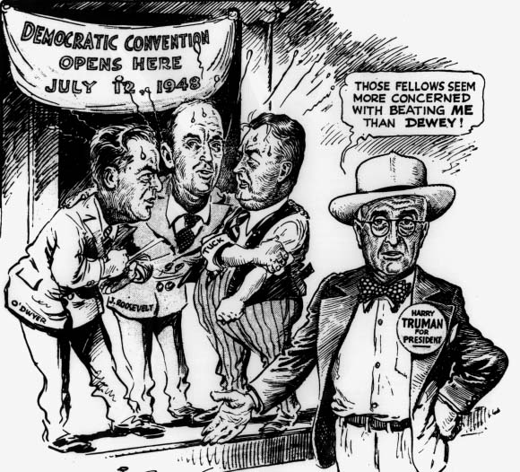
©1948, The Washington Post. Reprinted with permission.

Background Information

Harry S. Truman was the Democratic presidential candidate in 1948. His political views on civil rights (particularly his move integrating U.S. military forces), however, caused a split in the Democratic Party that year. Many Southerners who opposed Truman’s civil rights ideas left the party and started their own States’ Rights Party (also known as the Dixiecrats), nominating as their presidential candidate, Strom Thurmond. A similar split took place in the North, as left-wing Democrats bolted from the party and began the Progressive Party, nominating Henry Wallace for president. It was because of these divisions that many people believed Truman would lose the election. Not only did he have to contend with Dewey and the Republicans, but he also had to deal with those in his own party who were against him.

Instructions

Spend 2-3 minutes looking carefully at the cartoon. Using the Editorial Cartoon Analysis worksheet, examine the message and meaning of the cartoon.
Questions and comments can be addressed during class discussion.

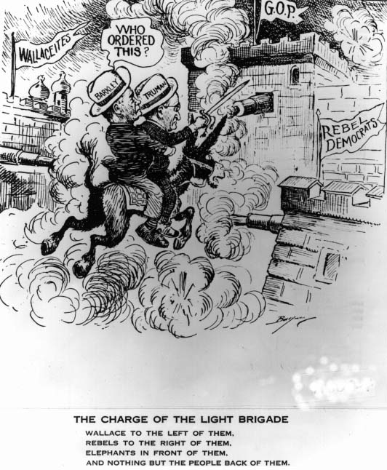

Background Information

As the president (and vice-presidential nominee Alben Barkley) proceeded with the campaign in 1948, it seemed that everyone was against Truman. Not only did he have to meet the Republicans head on, but splits on both the left and right sides of the Democratic party crippled the campaign. In the end, however, the people handed Harry S. Truman a landslide victory. He defeated the Republican candidate, Thomas Dewey, by 114 electoral votes and 2,136,525 popular votes in what has been called the greatest political upset of the 20th century.

Instructions

Spend 2-3 minutes looking carefully at the comic. Then, analyze the cartoon using the Editorial Cartoon Analysis worksheet. Questions and comments will be addressed during class discussion.
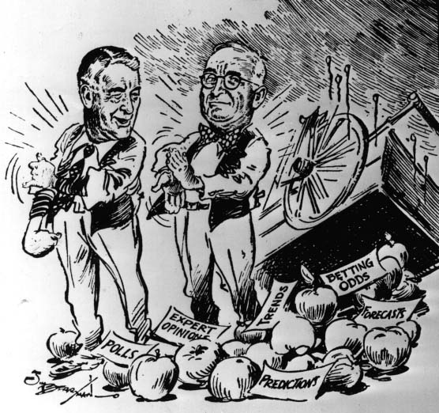
©1948, The Washington Post. Reprinted with permission.

Background Information

During the months and weeks preceding the election, polls and predictions universally said the same thing – Dewey would be the next president. In fact, by September of 1948, the Roper polling organization announced that it was ceasing its polls on the presidential race because “[there is] nothing duller or more intellectually barren than acting like a sports announcer who feels he must pretend he is witnessing a neck and neck race.” Truman ended up beating all of
the odds though, and captured the Oval Office in his own right.

Instructions

Spend 2-3 minutes looking carefully at the comic. Then, analyze the cartoon using the Editorial Cartoon Analysis worksheet. Questions and comments will be addressed during class discussion.

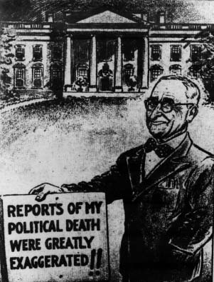
©1948, The Washington Post. Reprinted with permission.

Background Information

Even before the votes were cast, many journals and newspapers printed Truman’s political obituary. The most famous, of course, was the early edition of the Chicago Tribune which heralded, “Dewey Defeats Truman.” Throughout the entire 1948 campaign Harry S. Truman
was almost alone in his belief that he would win. When he did win the race for the White
House, he had a grand time poking fun at the nay-sayers who had predicted the demise of
his political career.

Instructions
Spend 2-3 minutes looking carefully at the comic. Then, analyze the cartoon using the Editorial Cartoon Analysis worksheet. Questions and comments will be addressed during class discussion.
Editorial Cartoon Analysis

1. Describe the action taking place in the cartoon

2. Explain the cartoonist’s message in the drawing and caption.

3. Is this cartoon easy to figure out? Why or why not?

4. Do you need a lot of background information on this issue, event or person to understand the cartoon?
__yes __no Explain.

5. Who is the cartoonist?

6. List any person(s) portrayed in the drawing:

7. Did the cartoonist exaggerate any physical features of a person? If yes, describe how it was done.

8. Were any symbols used? __yes __no If yes, what do they represent?

9. Which person or group(s) may be most likely to agree with its message?

10. Who (person or group) might not agree with the cartoon’s message? Explain why others
might disagree with the cartoon’s message.

11. In your opinion, should any topic be taboo for an editorial cartoon? Who should determine what is inappropriate or “off limits”? The cartoonist? The magazine or newspaper publisher?
How can a citizen express his/her opinion about a political cartoon?

