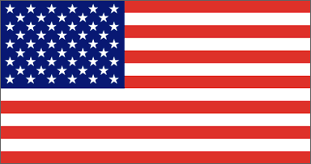
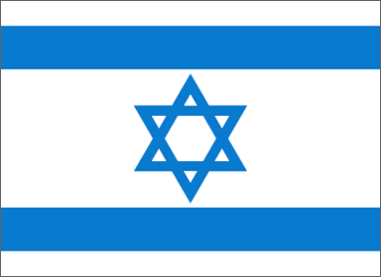
U.S. Recognition of Israel

Introduction

Following WWI, many Jews began to immigrate to Palestine, in hopes of eventually gaining a national homeland there. Tensions between the Arabs in the area and the Jews were great though, and by 1936 guerrilla fighting had broken out between the two groups. Unable to maintain peace, Britain (who was in control of the region at the time) restricted Jewish immigration into Palestine. The Jews, feeling betrayed, looked to the United States for support.

When Harry S. Truman took office, he made it clear that his sympathies were with the Jews. The Departments of War and State, however, recognizing the possibility of a Soviet-Arab connection and the potential Arab restriction on oil supplies to the U.S., advised against intervention on behalf of the Jews.

On April 2, 1947, the United Nations set up the Special Committee on Palestine (UNSCOP). This committee recommended that the British control over Palestine end, and that the territory be partitioned into two states – one Arab and the other Jewish. At midnight on May 14, 1948, the Provisional Government of Israel proclaimed a new State of Israel. On that same date, the United States, in the person of President Truman, recognized the provisional Jewish government as de facto authority of the Jewish nation.

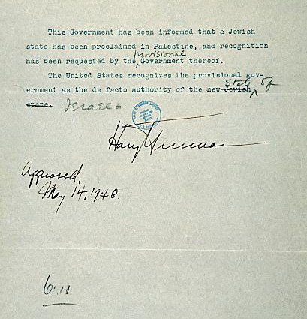
This is a reproduction of the press release issued by the United States government regarding the new state of Israel. It was signed by President Truman just 11 minutes after the Provisional Government of Israel proclaimed the new state – making the U.S. the first nation to recognize Israel. After studying the document and the above text carefully, answer the following questions.

- Using a dictionary or your textbook, define both de facto and de jure. (Note: de jure recognition was granted to Israel on January 31, 1949)
- Look carefully at the wording changes that were made. Why do you think the document was edited in this way?

- Below, make a list of the possible risks and benefits of that Truman’s decision to recognize Israel might have incurred. Keep in mind factors such as: Truman’s lifelong friendship with Eddie Jacobson (a Jewish man from Kansas City); the upcoming presidential election; the United States dependency on Arab oil.

RISKS BENEFITS

- Taking into consideration all of the risks and benefits listed above, what would you have done in the same situation. Why?

- Why do you think U.S. recognition of the State of Israel was so significant at the time?

U.S. Recognition of Israel
Teacher’s Guide

Answers

- de facto – in reality or in fact, actually exercising power though not officially established
de jure – by right or according to law

- The provisional was added to account for the fact that the governing body of the new state of Israel was not yet an official government. The Jewish state was changed to the State of Israel to clarify the territory – also because when the original press release was written the name of the Jewish state was not yet known.

- Possible answers include:

RISKS BENEFITS

-Soviet intervention on behalf of -Jewish support in the 1948 election
the Arabs.
-National commendation for an act that
-the loss of valuable supplies of Arab was popularly favored among American
oil citizens

-possibility of war between Arabs -finally, a national Jewish homeland
and Jews (which may then bring in
the U.S. and the Soviet Union) -remaining friends with Eddie Jacobson
and staying in the favor of Jewish leaders
-political backlash from anti-Semitics
both at home and abroad

- Every answer will differ. Remember that the most important part of the question is “WHY”. Students may choose to respond to the situation as they wish, but they need to be able to defend their position.

- U.S. recognition was significant for many reasons. Primarily, the recognition of the world’s superpower gave credibility to the new nation and also a support system to depend upon. The actions of the U.S. also served as a model for other nations to follow.

